Importing and configuration of SSL Certificate

1. Open mmc console, and add **Certificates** snap-in using computer account option: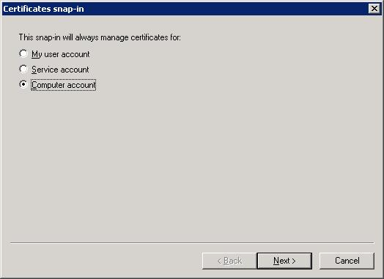

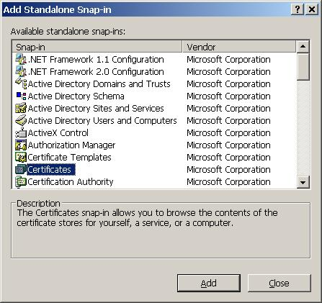

1. After adding Certificates snap-in, open and right-click on Personal\Certificated folder, and select **All Tasks > Import**:

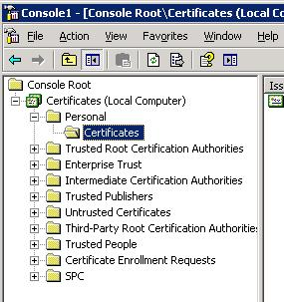

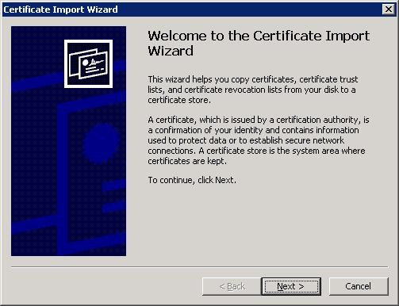

1. Press Next, and on the next screen click “**browse**” button and select the PFX file from the location below (I have already copied the pfx file to both servers):  
   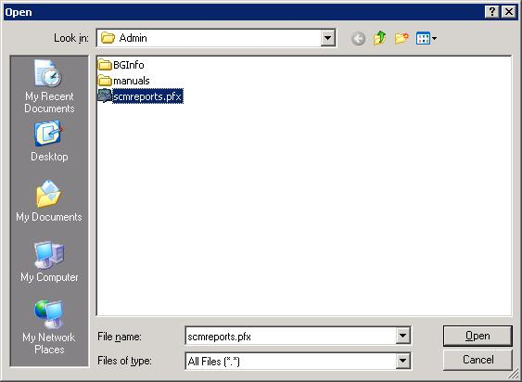

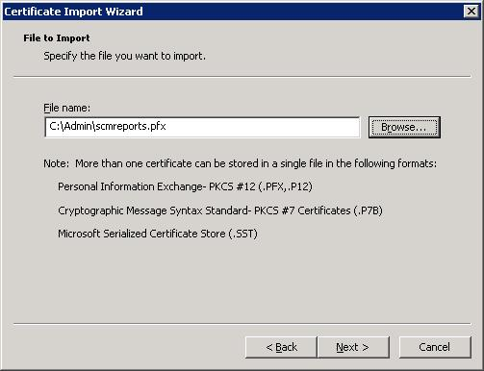

1. Press next and enter the password that I handed you:  
   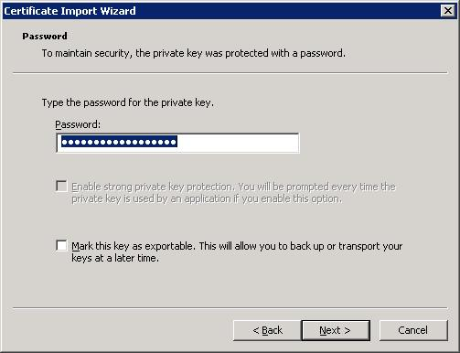
2. Press next, and the next screen should look like this:  
   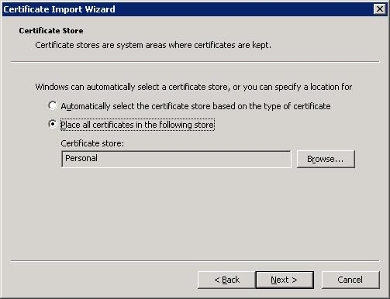
3. Accept the default and press next:  
   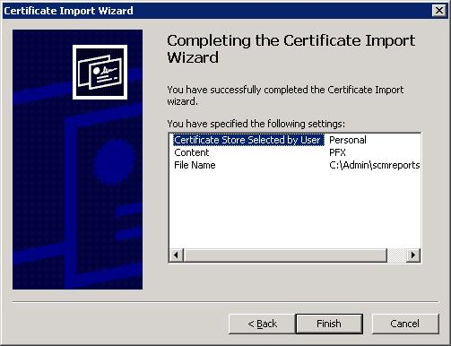
4. Press finish, and continue with:  
   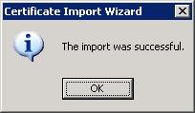
5. Open IIS manager, and right-click on “**Default Web Site**” and select properties as follows:  
   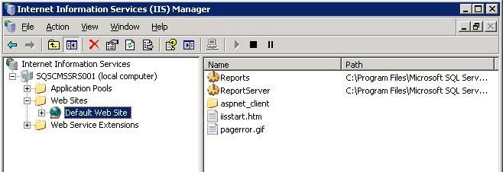
6. Click “**Server Certificate**” button:  
   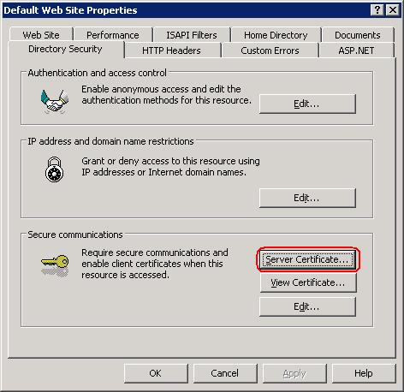
7. Select “Replace the current certificate” option:  
   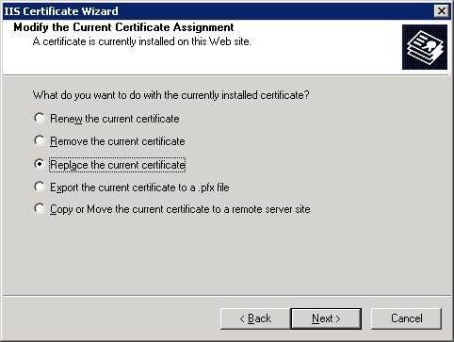
8. Select the imported certificate from the pfx file in previous steps:  
   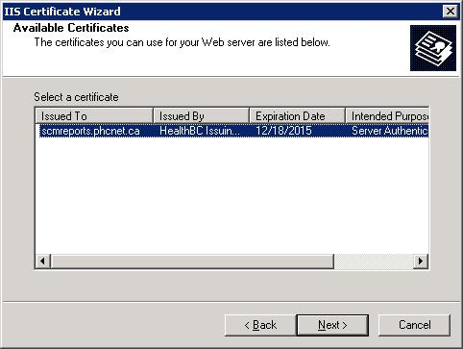
9. Press next, and the last screen should look like this:  
   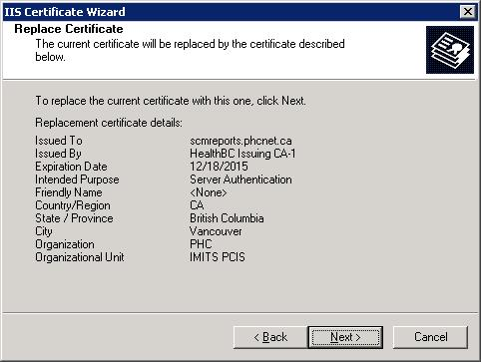
10. Press next and finish.